Managing EC2 with Boto3

1. Introduction to Boto3
Boto3 is the Amazon Web Services (AWS) SDK for Python. It allows Python developers to write software that makes use of services like Amazon EC2, S3, and many others.
With Boto3, you can:
- Automate cloud tasks
- Manage AWS resources programmatically
- Build scripts to start, stop, or terminate EC2 instances
In this guide, we’ll focus on managing EC2 instances.

2. Installation of Boto3
Make sure you have Python installed. Then install boto3 using pip:
pip install boto3
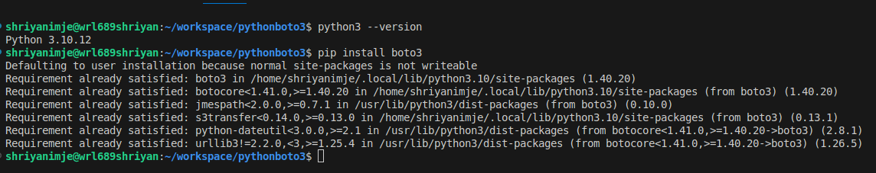
3. AWS Configuration
Boto3 needs AWS credentials to connect to your account. Configure them with the AWS CLI:
- Install AWS CLI (if not already installed):
pip install awscli
- Configure your credentials:
aws configure
Enter:
  - AWS Access Key ID
  - AWS Secret Access Key
  - Default region (e.g., us-east-1)
  - Output format (json, text, or table)
This creates a credentials file at ~/.aws/credentials that boto3 will use.
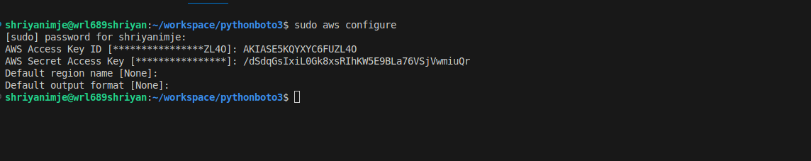
4. Task: EC2 Lifecycle Management
We’ll create a Python script (manage_ec2_task.py) to list, start, stop, reboot, and terminate EC2 instances.
Script
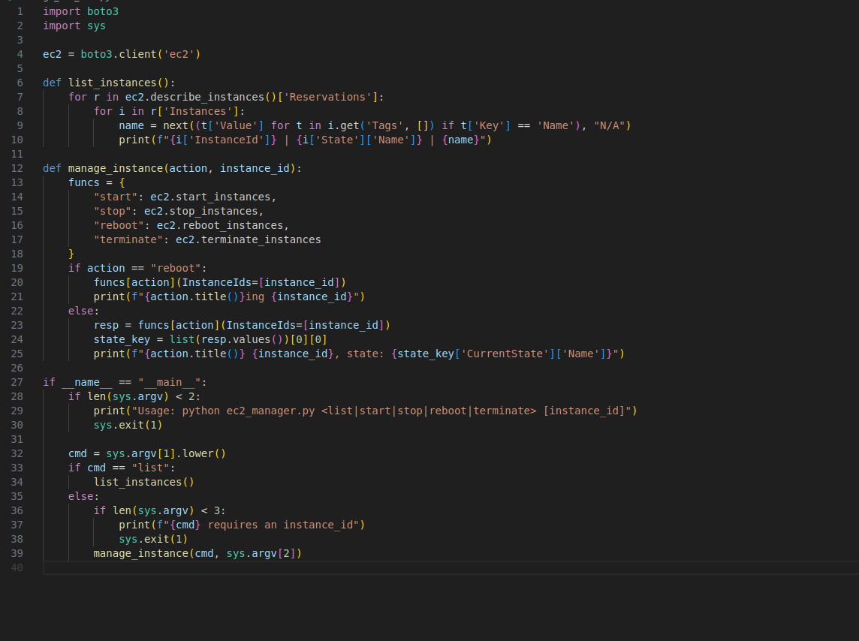
5.Working
- create instance:
  - python3 manage_ec2_task.py create
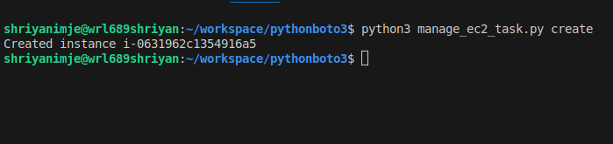
- List all instances:
  - python3 manage_ec2_task.py list
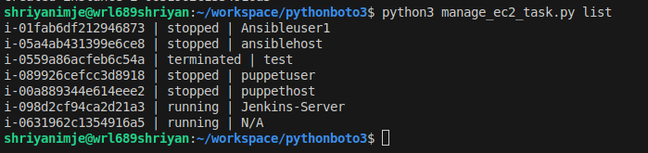
- Start an instance:
  - python3 manage_ec2_task.py start i-0631962c1354916a5
- Stop an instance:
  - python3 manage_ec2_task.py stop i-0631962c1354916a5
- Reboot an instance:
  - python manage_ec2_task.py reboot i-0631962c1354916a5
- Terminate an instance:
  - python manage_ec2_task.py terminate i-0631962c1354916a5

Shell Script: Archive Logs with Email Alert
1. Purpose
This script automates the process of:
- Finding .log files older than a set number of days.
- Compressing them into a .tar.gz archive.
- Sending an email alert with the status of the operation.

2. Script
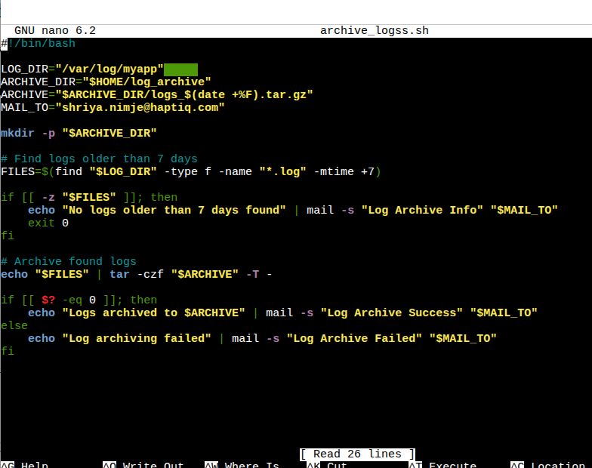
3. How It Works
- Locate old logs
  - Uses find to search for *.log files in $LOG_DIR older than $DAYS days.
- Archive
  - Compresses the results into a .tar.gz file in $ARCHIVE_DIR.

4. Email Alert
  - Success → mail subject: Log Archive Success
  - Failure → mail subject: Log Archive Failed
  - No logs → mail subject: Log Archive Info
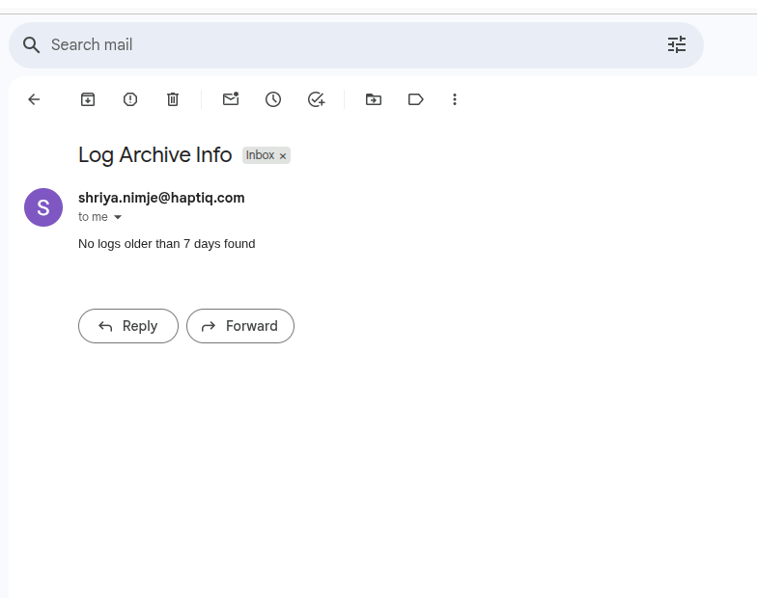
- Automating it with cron :
crontab -e
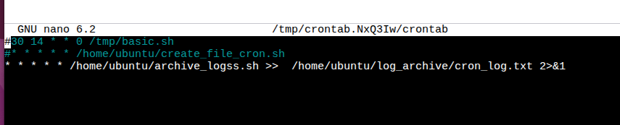
2. cron job is running after each min
